Appswatch Guide

Document History

|  |  |  |  |
| --- | --- | --- | --- |
| Version | Date | Author | Changes |
| 1.0 | 02-Jul-2018 | Jayadeep Rajan | First version |

Contents

1. General Information 2

1.1. Objective of the Document 2

1.2. Intended Audience 2

2. Introduction 3

2.1. What is Appswatch? 3

2.2. Appswatch Architecture 3

2.3. S2 Servers 4

3. Appswatch Dashboard 5

4. ScenarioStations Manager 6

5. ScenarioBuilder 9

5.1. Viewing the Existing Scenarios 9

5.2. Create a New Scenario 11

5.3. Configuring Dashboard 15

5.4. Edit an Existing Scenario 20

5.5. Deleting a Scenario 21

6. Committing to Git 24

6.1. Steps 24

6.2. In Detail 25

7. Contact 26

8. Reference 26

## General Information

## Objective of the Document

The objective of the document is to provide members of the delivery team with an overview of the application. The document describes the function of the application, the structure of the application and the technical environment.

## Intended Audience

The document is intended mainly for any person who wants to know the details of the Appswatch Platform that is used in the Apps2 Shared Services.

## Introduction

## What is Appswatch?

AppsWatch is NRG Global’s application monitoring solution that tackles the ultimate performance monitoring challenge: Measuring availability and response times of ANY application from the end-user’s perspective.

## Appswatch Architecture

The AppsWatch Suite consists of three components – AppsWatch Base, ScenarioStation, and ScenarioBuilder. Together, they comprise NRG Global’s performance monitoring solution for your environment. 1

1. **AppsWatch Base** – Install on a Windows PC or Windows Server. Installation creates the Base, the virtual console which opens in a browser and from which performance testing monitors are configured and managed.
2. **ScenarioStation** – Install on a Windows PC or Windows Server. The station simulating real-user interactions against the application under test with a specified frequency. The robot that executes and runs tests configured in the Base.
3. **ScenarioBuilder** – Install on a Windows PC or Windows Server. The test scripting tool that understands and interacts with any application accessible from a graphical user

AppsWatch accurately monitors response time from the user standpoint because robots on ScenarioStations repeatedly generate scenarios exactly as a real user would. ScenarioStations are situated at your key locations and report response times to the AppsWatch Base. Organized views of data for troubleshooting, SLA reports, graphs, and alerting controls are available from the AppsWatch Base.



## S2 Servers

The list of servers used in S2 is provided below

|  |  |  |  |
| --- | --- | --- | --- |
| **Sl #** | **Server Name** | **Type** | **IP Address** |
|  | FRPARAPWBASE | Appswatch Base | 10.24.203.147 |
|  | FRPARAPWINJCT1 | Scenario station 1 | 10.24.203.21 |
|  | FRPARAPWINJCT2 | Scenario station 2 | 10.24.203.45 |

The user name to access the servers is **ADM-FR-APPSWATCH**.

## Appswatch Dashboard

The URL of appswatch is <https://appswatch.s2-eu.capgemini.com/main/index.php>

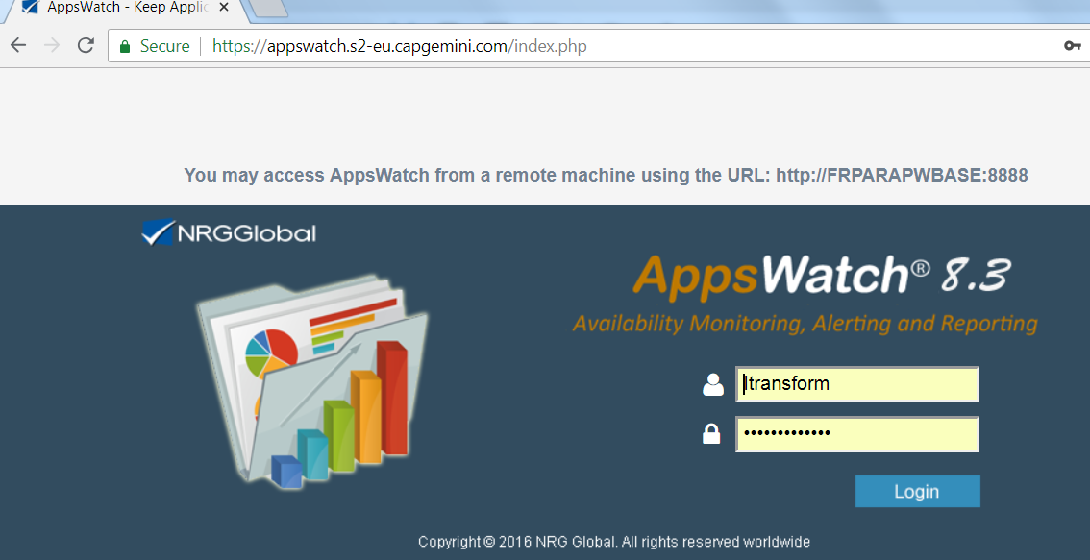

Log in to AppsWatch (User Name: Itransform / Password: xxxxx)

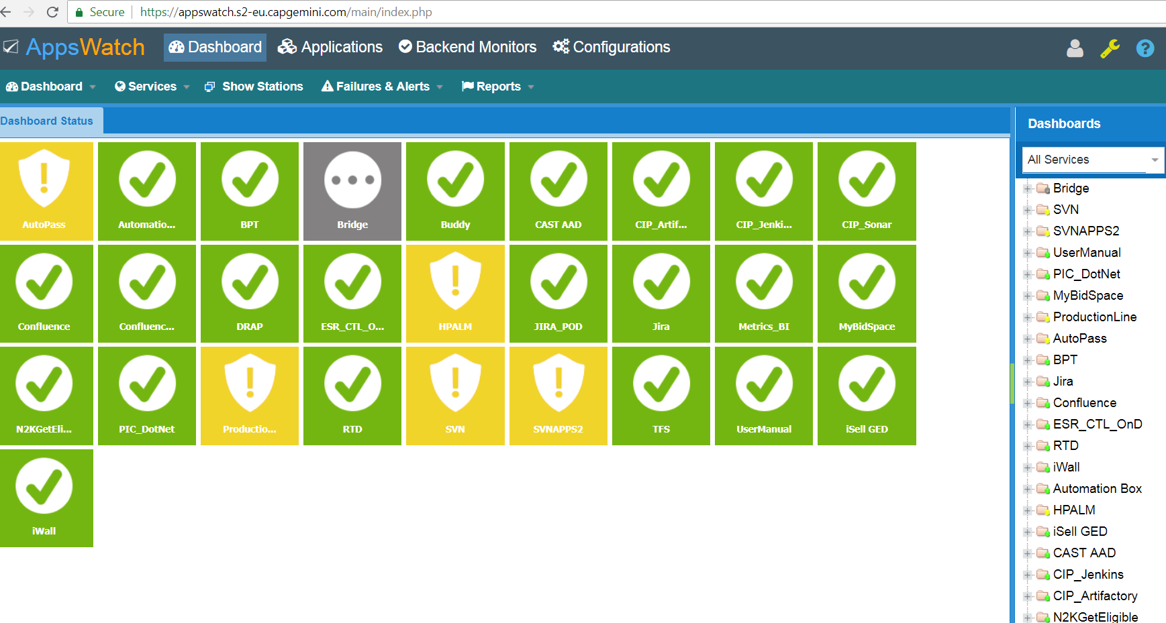

## ScenarioStations Manager

The SSrdp Manager is another option that is offered by AppsWatch to monitor ScenarioStations. SSrdp Manager allows users to create RDP connections to one or all the ScenarioStations. Through these connections the user can create Scenarios and monitor the ScenarioStations.

Once you install AppsWatch, SSrdpManager will also be installed. You can find it in the AppsWatch’s folder in program menu.

1. **Click on the SStationManager icon**

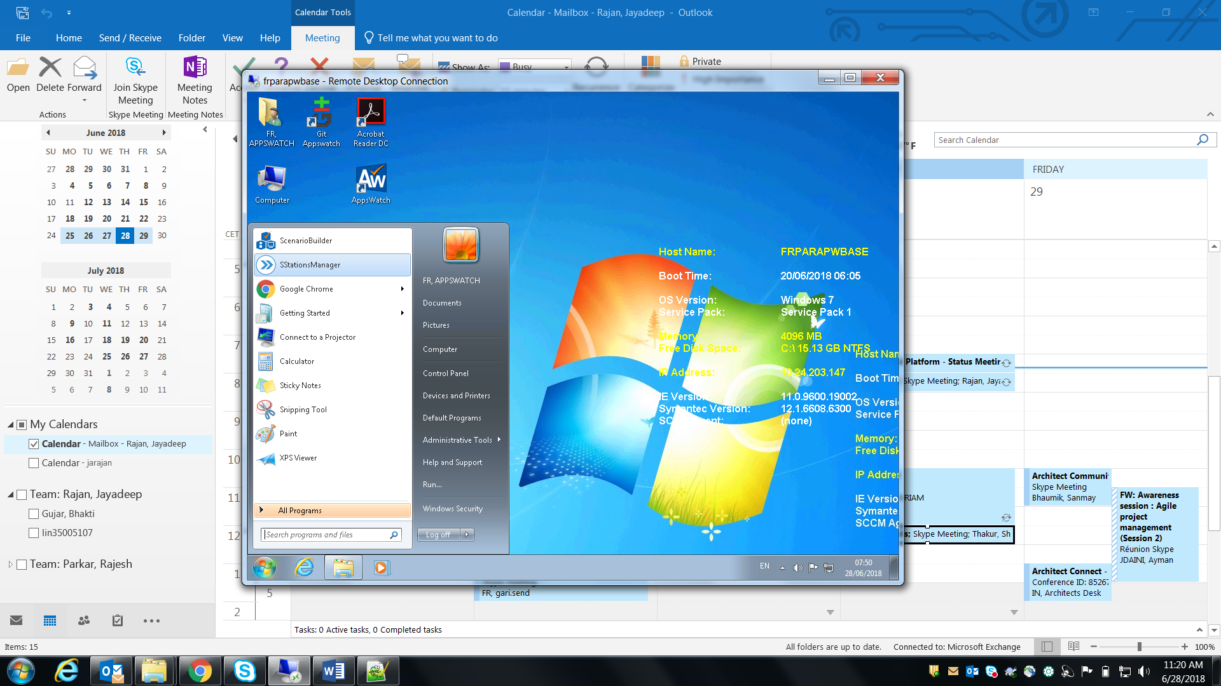

The **SSrdpManager** will open

1. **To open a connection file, click “Open a connection file” .**

The configuration file for S2 is C:\SSRDMgr\Apsw_SS.srdp file

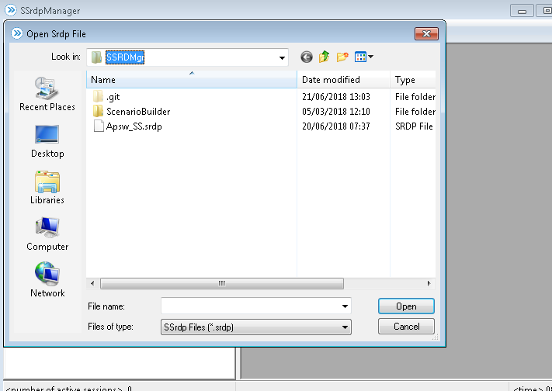

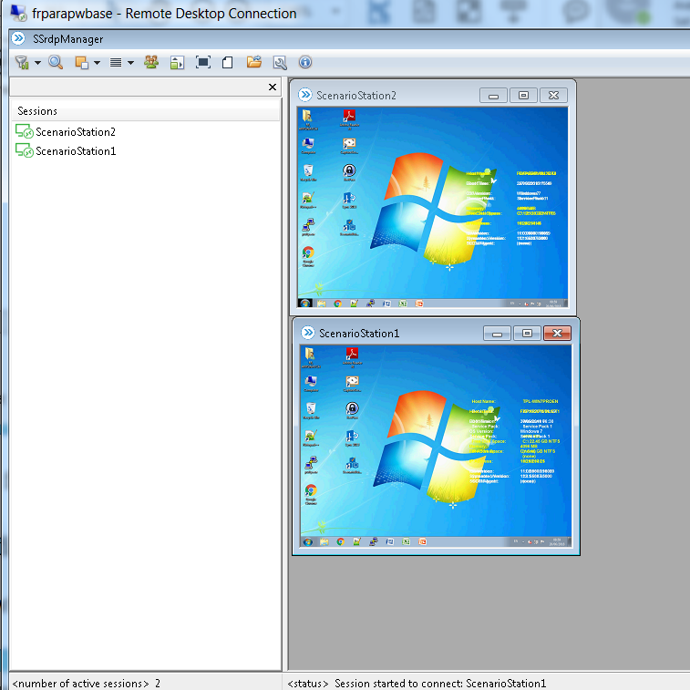

1. **To edit a connection file, click “Edit connection file” **

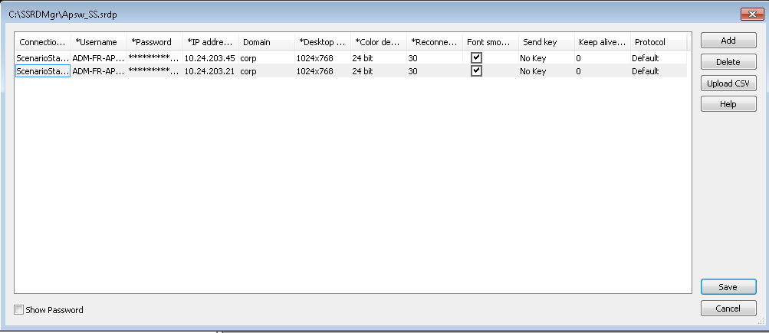

Make the necessary changes and save the file.

## ScenarioBuilder

ScenarioBuilder is the tool used to create real life Scenarios replicating the actions of users.

## Viewing the Existing Scenarios

1. **Click on the ScenarioBuilder icon**

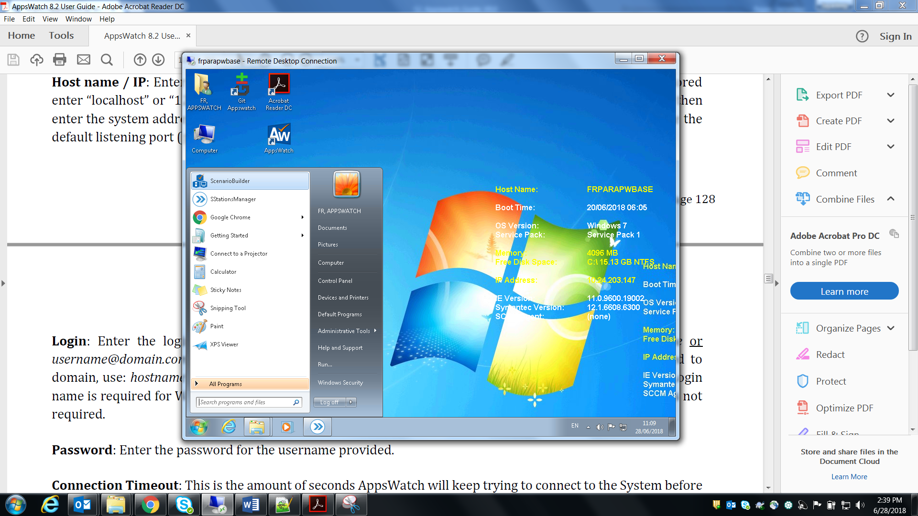

The editor will appear

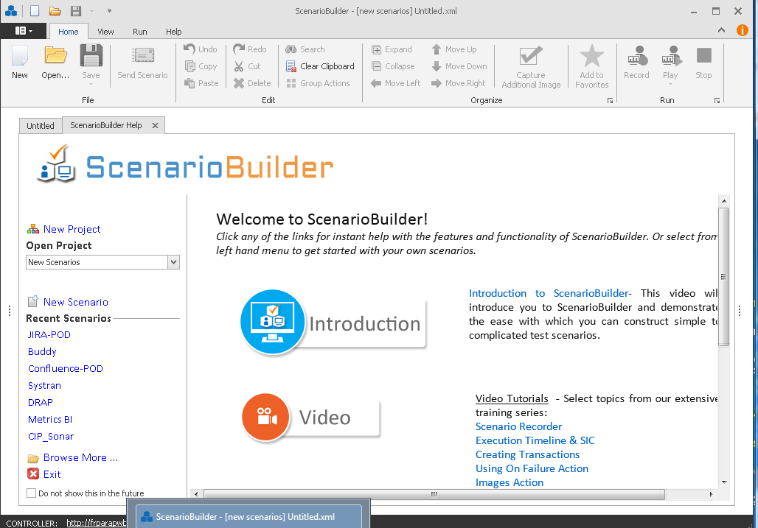

1. **View the list of scenarios**

On clicking the Open icon, the list of existing scenarios will appear as shown below.

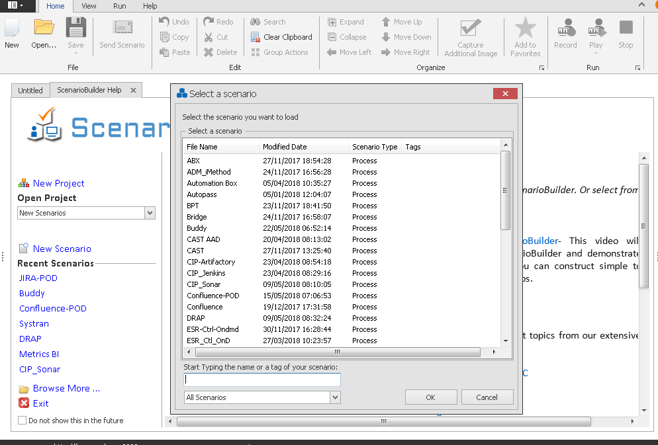

## Create a New Scenario

1. Click on the new button

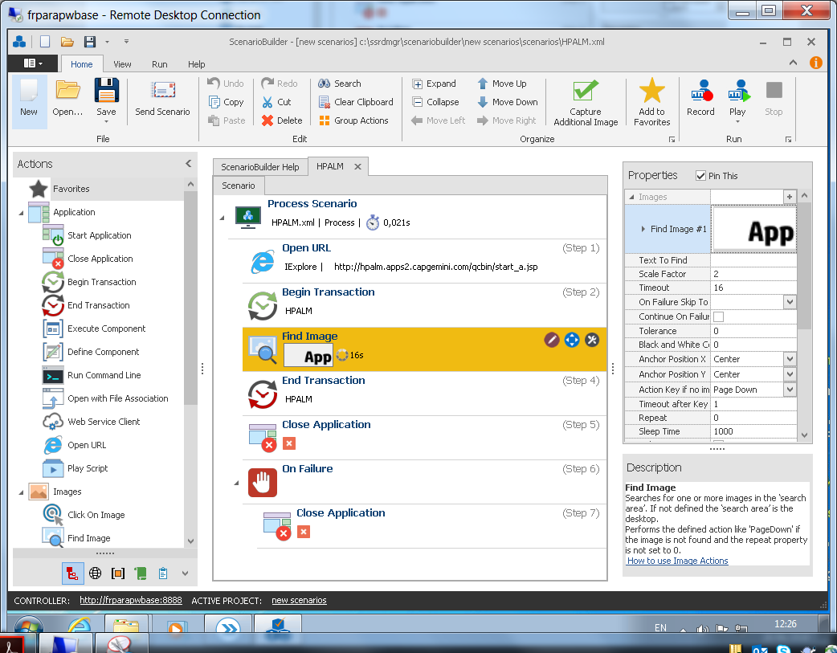

1. Enter the name of the new scenario to be created and click on “Open web app”

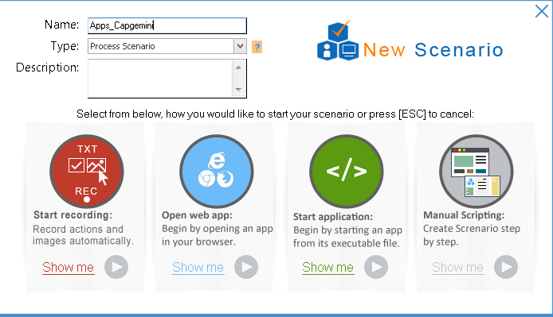

1. Enter the URL of the web application and select the browser and click OK.

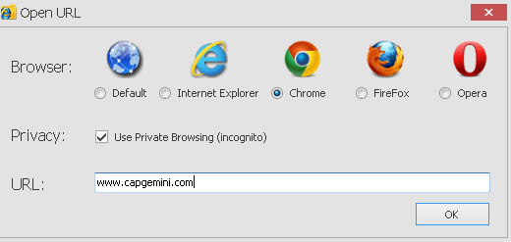

1. The requested page will be opened in the browser

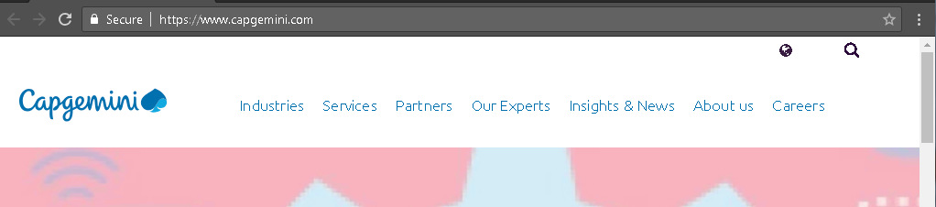

1. Click on the text/image that needs to be identified on the page (Here the Capgemini logo) and then the close icon on the browser. The steps will be shown on the editor.Add the additional steps by dragging it from the tool bar on the left side and save the changes.

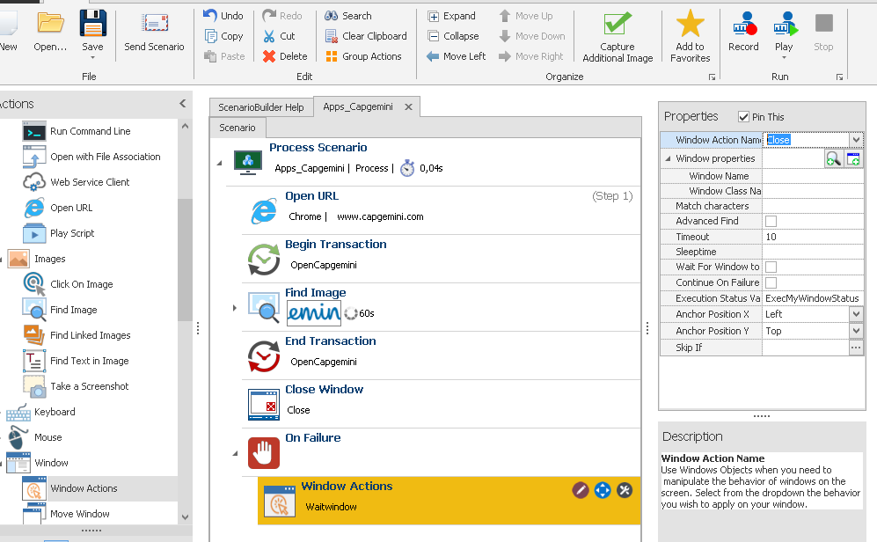

1. Test the changes by clicking the “Play one iteration” button.

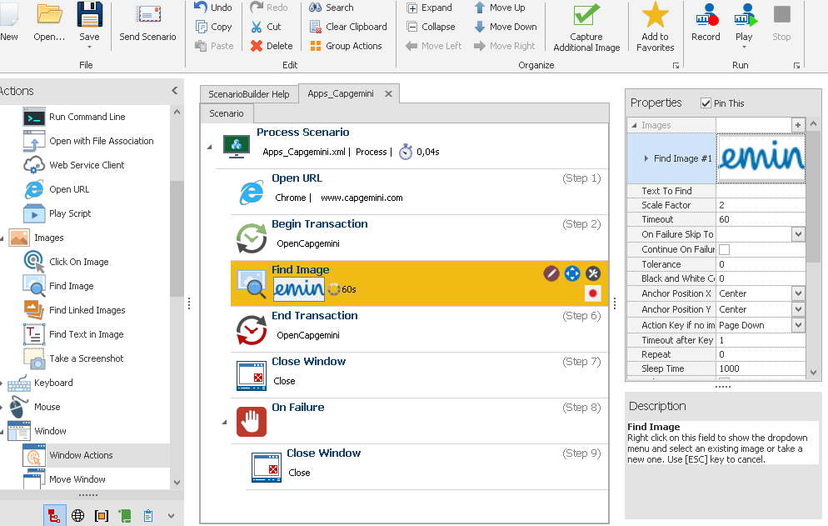

1. The scenario will be played on the browser and look for the Capgemini logo, if the scenario is played correctly, the following dialog box will be displayed.

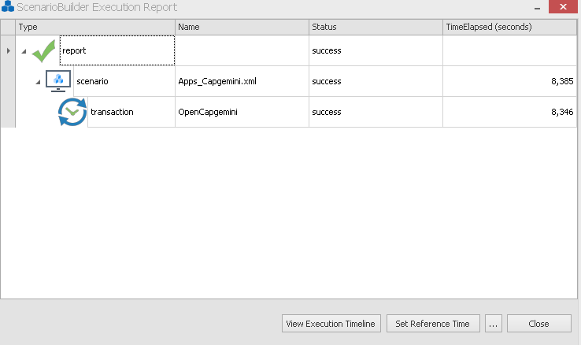

1. Send the scenario to the Scenario Station by clicking on the “Send Scenario” button.

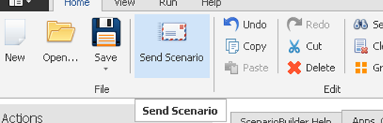

The following dialog box will be displayed

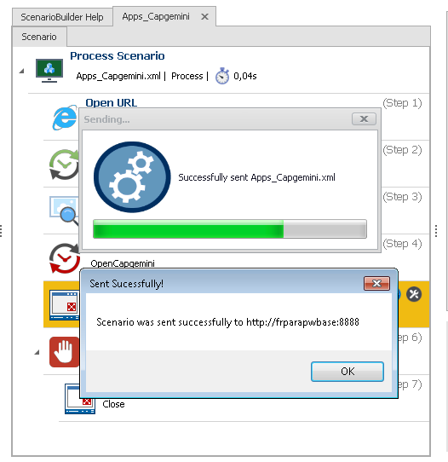

## Configuring Dashboard

1. Login to Appswatch, Click on Applications, Application Manager

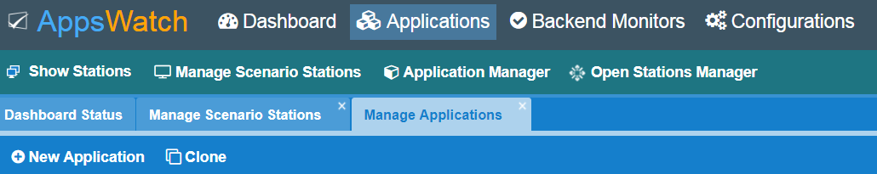

1. Click on “New Application” and enter the required parameters, submit and close the window.

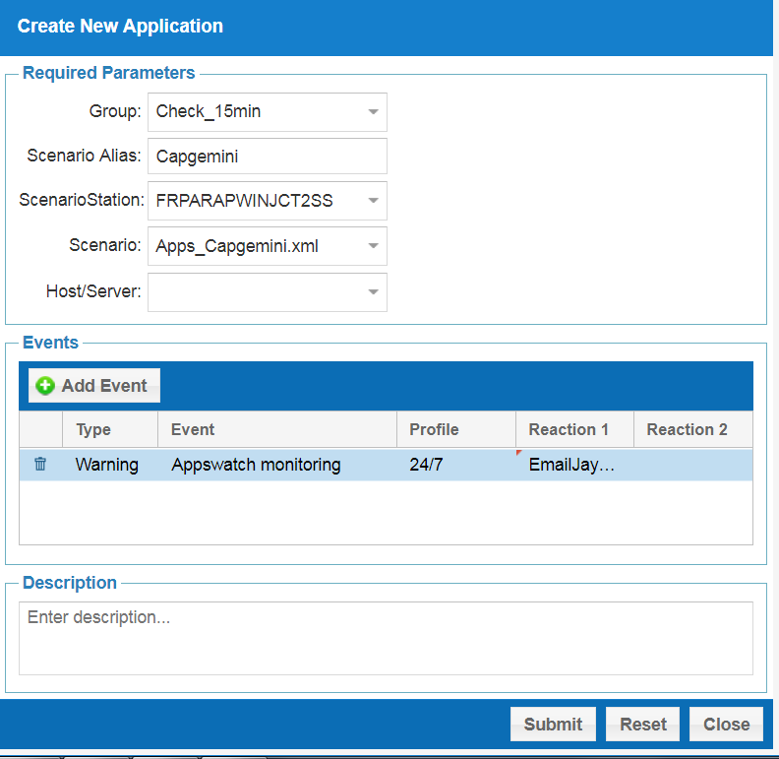

1. The new application will be added to Appswatch and will be shown under the Scenario station which the application is added.

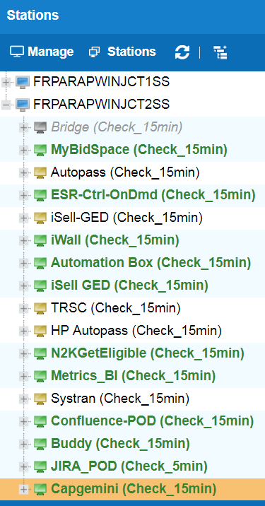

1. To add the new application to the Dashboard, Click Dashboard -> Services -> New Service. The “Create New Service” screen will appear. Enter the required name under “Service Alias”. The same name will appear on the right side of the panel.

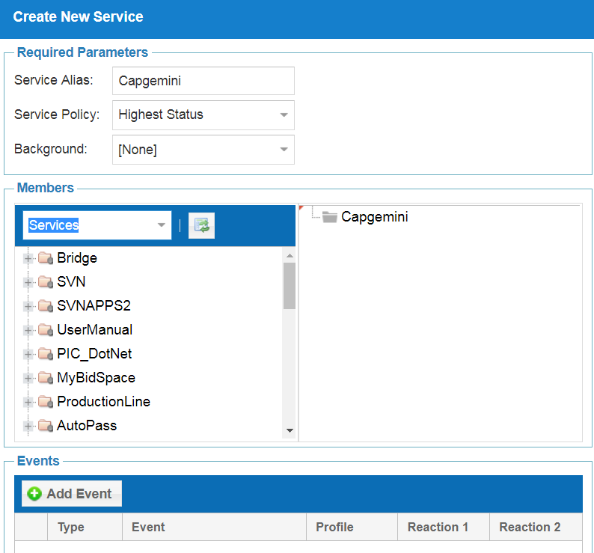

1. Change the dropdown list from Services to Applications

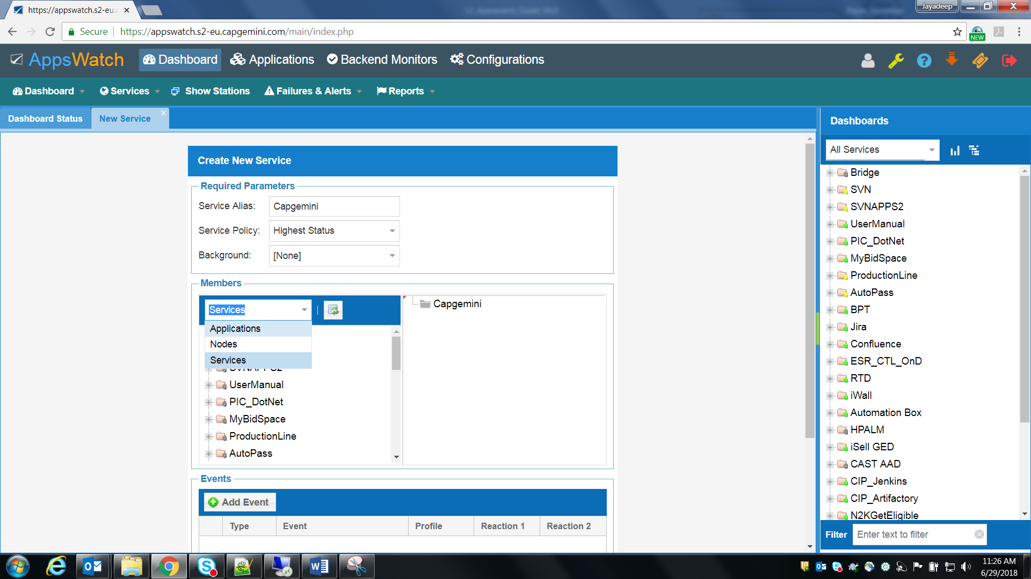

1. The Application Name along with the Transaction Name will appear

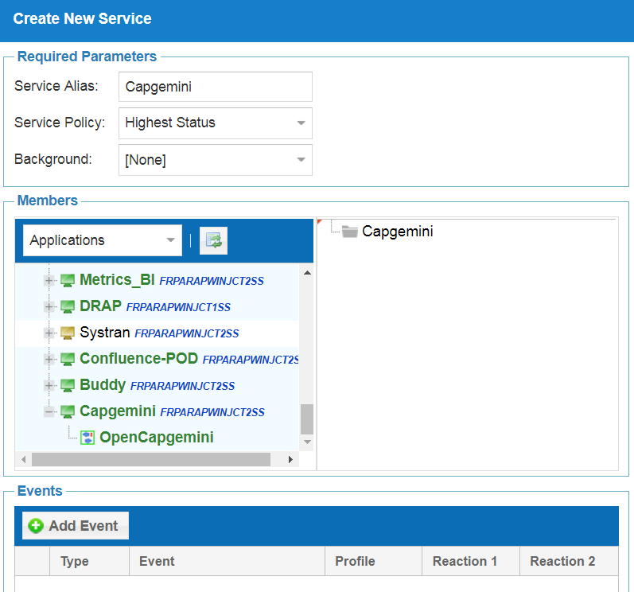

1. To add the Transaction to the Service, drag the the Application to the Alias on the right side.

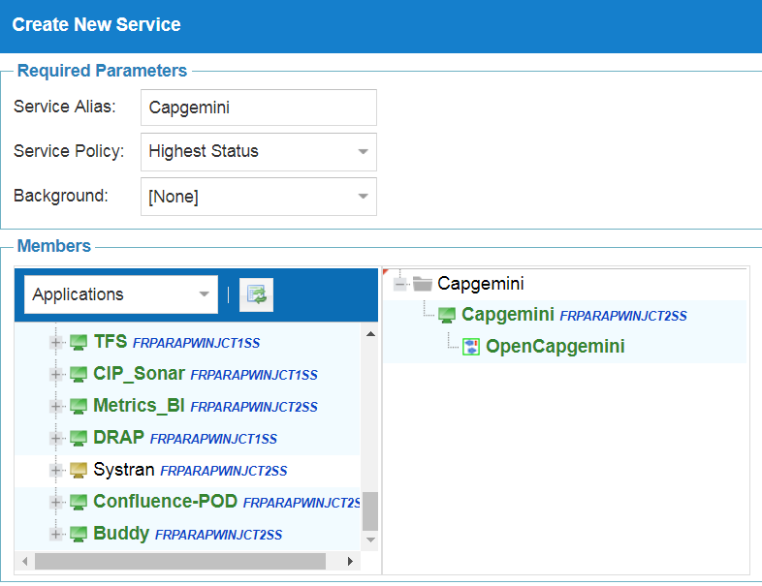

1. The application is now added to the dashboard.

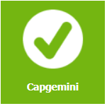

The details will also be displayed under the services.

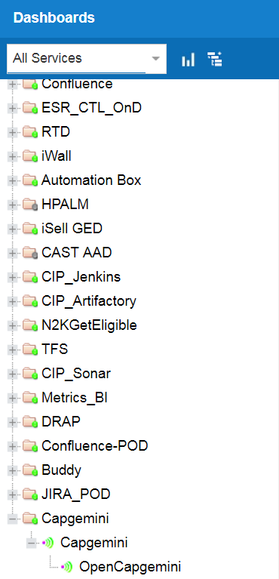

## Edit an Existing Scenario

1. From the list, select the scenario that needs to be modified.

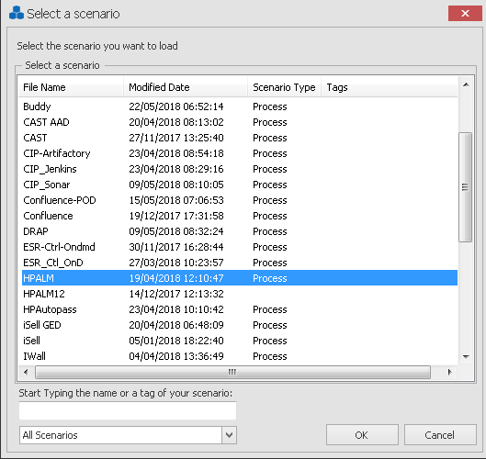

1. The script for the selected scenario will be opened.

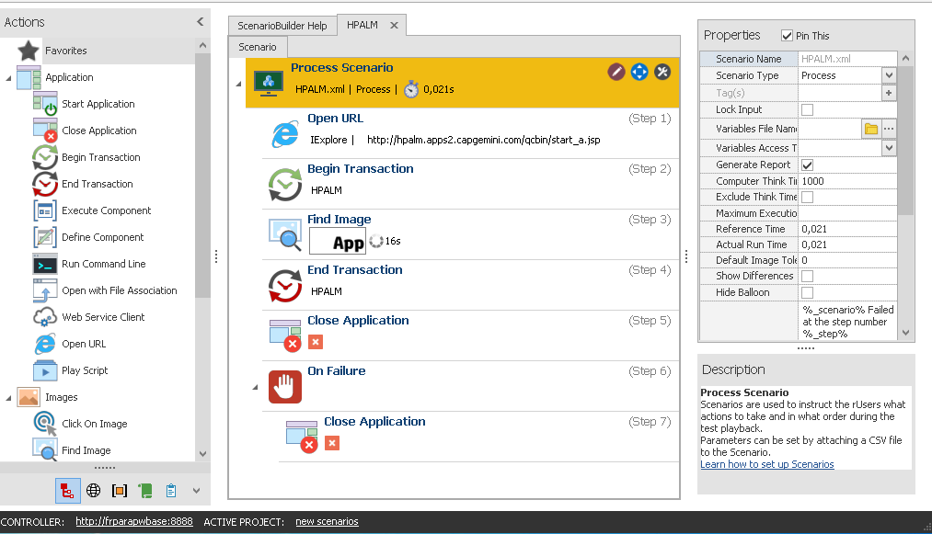

Make the necessary changes and save the file.

1. Follow the steps 6, 7 and 8 on Create a New Scenario.

## Deleting a Scenario

1. Right click on the scenario to be deleted under “All Services”.

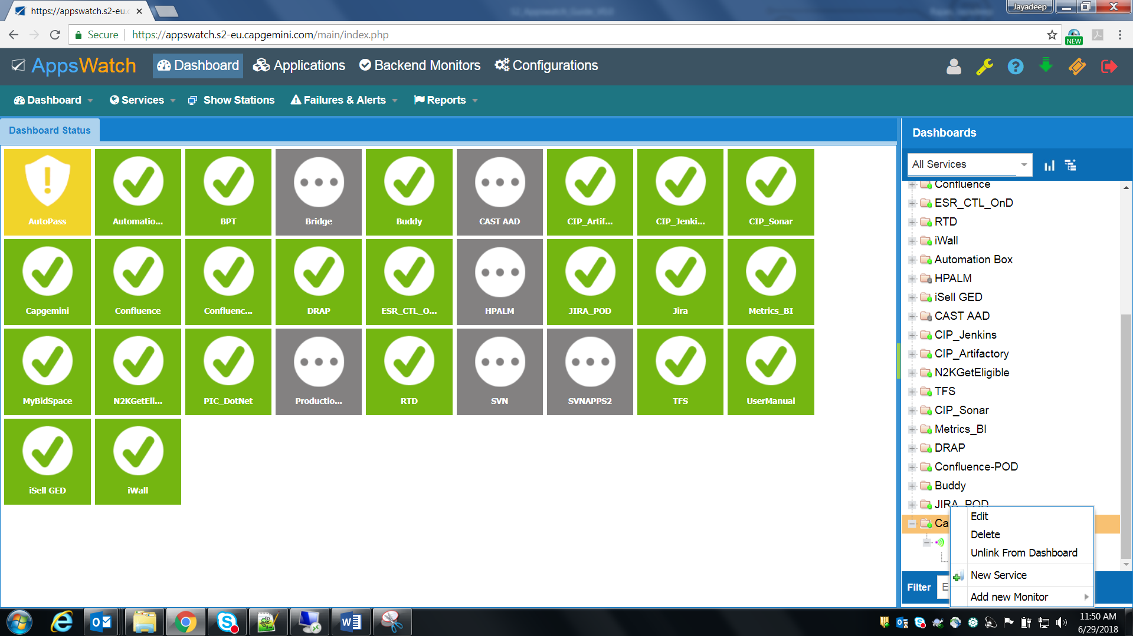

1. Click on the Delete button and confirm the deletion

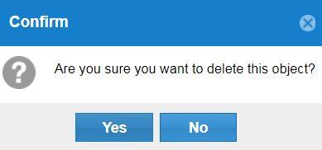

1. Open the ScenarioBuilder in the base station, click on View -> Scenario/Components Manager.

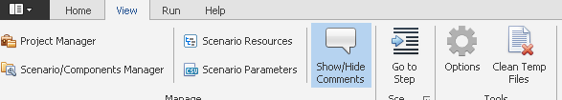

1. The list of scenarios will be displayed

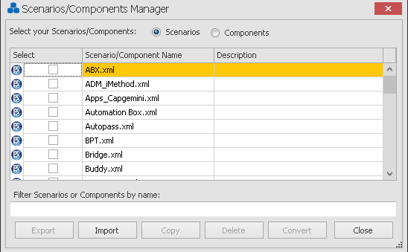

1. Enter the name of the scenario to be deleted, the scenario file will be displayed.

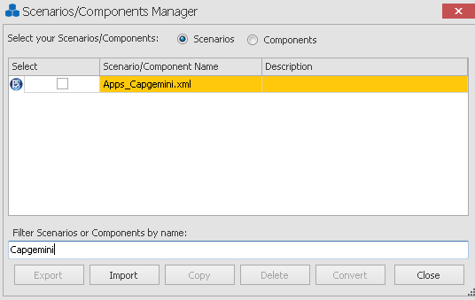

1. Select the check and click the Delete button, the scenario will be deleted.

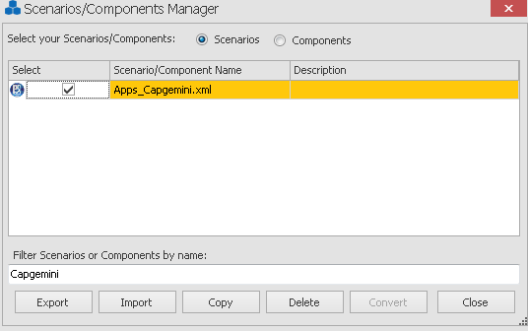

## Committing to Git

## Steps

The configuration file “C:\SSRDMgr\Apsw_SS.srdp” and the scenario files under “C:\SSRDMgr\ScenarioBuilder\New Scenarios\scenarios” are stored in the GIT repository <https://plrunteam.pl.s2-eu.capgemini.com/gerrit/p/appswatch.git>.

The steps are provided below.

1. Stage new and modified files to the local gitlab

**git add ScenarioBuilder/New\ Scenarios/scenarios/<file-name>**

1. Commit the local changes that were staged

**git commit -m "Committed All the files"**

1. Push the changes to the remote branch

**git push --set-upstream https://plrunteam.pl.s2-eu.capgemini.com/gerrit/p/appswatch.git master**

## In Detail

1. The commands

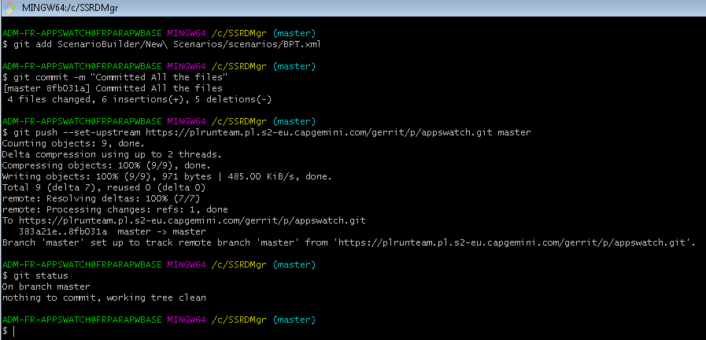

1. Web Interface

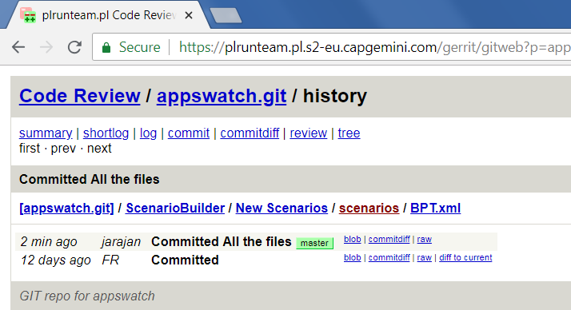

## Contact

|  |  |  |
| --- | --- | --- |
| Name | Email | Role |
| RUN team | itransformsupport.ma@capgemini.com | S2 Contact |
| NRG Global | support@nrgglobal.com | Tool Support |

## Reference

[Appswatch User Guide](https://www.nrgglobal.com/hubfs/sdl/appswatchuserguide.pdf).

About Capgemini

With more than 190,000 people, Capgemini is present in over 40 countries and celebrates its 50th Anniversary year in 2017. A global leader in consulting, technology and outsourcing services, the Group reported 2016 global revenues of EUR 12.5 billion. Together with its clients, Capgemini creates and delivers business, technology and digital solutions that fit their needs, enabling them to achieve innovation and competitiveness. A deeply multicultural organization, Capgemini has developed its own way of working, [the Collaborative Business Experience™](http://www.capgemini.com/about/how-we-work/the-collaborative-business-experiencetm), and draws on [Rightshore®](http://www.capgemini.com/about/how-we-work/rightshorer), its worldwide delivery model.

Learn more about us at www.capgemini.com.

This message is intended only for the person to whom it is addressed. If you are not the intended recipient, you are not authorized to read, print, retain, copy, disseminate, distribute, or use this message or any part thereof. If you receive this message in error, please notify the sender immediately and delete all copies of this message.

This message contains information that may be privileged or confidential and is the property of the Capgemini Group.  
Copyright © 2017 Capgemini. All rights reserved.

Rightshore® is a trademark belonging to Capgemini.